Epsom & Ewell F.C.
20
v
Bedfont & Feltham F.C.
Saturday, 21st January 2017 – 3.00 p.m.
Good afternoon! We welcome the players, supporters and officials of Bedfont and Feltham Football Club, today’s officials and of course, our own regular faces for today’s League match.

We have hosted both Bedfont and Feltham clubs over the years, but this is the first time we have hosted them since they merged back in May 2012. We have of course met once already this season when a most bizarre match took place at the Orchard on the opening evening of the season as we trailed 2-0 at half time, only to score nine goals in the second half for a resounding 9-2 victory!

Their first season at this level has been a struggle for them and although time remains to escape relegation, it will be a fine achievement if they can do it. We wish them well in their task but obviously not today!

We were last here on Tuesday when Guildford City made the second of their two visits in seven days, this time for a League match, and a Craig Hastings header gave us the three points from a 1-0 win. It was deserved and maybe we should have killed the game off sooner but they rarely threatened us at the back. It was also nice to get revenge for the Surrey Senior Cup defeat!

Our next match is on Tuesday when we journey to Bedfont & Feltham for a League match with CB Hounslow United, hoping to redeem ourselves after an awful 5-1 home defeat back in August. It is a measure of our character that we have not lost a home league match since that date.

We then have two more away matches, firstly at AFC Hayes on Saturday 28th January and then three days after that at Stompond Lane for the Quarter-Final of our League Cup tie against Walton & Hersham, before returning here two weeks today for a League match against Badshot Lea.

We are also still looking for match and player sponsors, so if you would like to help us, please speak to any Committee Member and we can arrange this for you. The cost of a sponsorship is £55 while player sponsorship is £40. If you represent a company, we can provide an advert too.

I will end by welcoming many former supporters today. We have recently commemorated the 30th anniversary of the formation of Epsom & Ewell Supporters F.C. who rose to Division One of the Leatherhead & District League during its 15 year existence. I was the Chairman and Manager of the club for the first thirteen of those and many former players who used to watch us back in the eighties and even some who played for the club will be present today. It will be great to see you all again, and in Epsom this evening where we shall be marking the anniversary “properly”!

Enjoy the game!

Rich

You can follow us on Facebook: www.facebook.com/epsomandewellfc
Twitter: @EEFCOfficial Instagram at: www.instagram.com/epsomandewellfc
and on Youtube at: www.youtube.com/channel/UCtLrpS0x5OaYUACRT34_zng

Today’s Cover Photos

- Recent birthday boy Elliott Thompson scores a great free kick at Bedfont & Feltham in August

- Epsom & Ewell Supporters F.C. in 1989. Note the sponsors, full story in programme

Cherry Red Records Combined Counties League
Premier Division Table 2016/17
incl Tuesday 17th January | P | W | D | L | F | A | Pts | GD | H | A
Hartley Wintney | 29 | 24 | 3 | 2 | 95 | 28 | 72 | +67 | 18/3 | 1-3
Westfield | 27 | 17 | 6 | 4 | 62 | 31 | 57 | +31 | 18/2 | 1-2
Hanworth Villa | 30 | 17 | 5 | 8 | 51 | 33 | 56 | +18 | 2-2 | 0-1
Horley Town | 27 | 15 | 5 | 7 | 64 | 41 | 50 | +23 | 3-0 | 17/4
Walton & Hersham | 27 | 13 | 11 | 3 | 45 | 26 | 50 | +19 | 4/3 | 1-1
Camberley Town | 27 | 14 | 4 | 9 | 56 | 32 | 46 | +24 | 0-0 | 1/4
Epsom & Ewell | 27 | 13 | 7 | 7 | 59 | 38 | 46 | +21 | X | X
Knaphill | 27 | 14 | 3 | 10 | 56 | 50 | 45 | +6 | 4-0 | 8/4
Windsor | 29 | 11 | 6 | 12 | 55 | 50 | 39 | +5 | 2-0 | 1-2
Guildford City | 31 | 11 | 6 | 14 | 61 | 65 | 39 | -4 | 1-0 | 2-0
Abbey Rangers | 28 | 11 | 5 | 12 | 47 | 52 | 38 | -5 | 7-1 | 20/2
Bedfont Sports | 26 | 11 | 5 | 10 | 45 | 50 | 38 | -5 | 5-1 | 7/2
North Greenford United | 25 | 10 | 4 | 11 | 51 | 47 | 34 | +4 | 22/4 | 1-2
Colliers Wood United | 25 | 9 | 7 | 9 | 42 | 42 | 34 | 0 | 14/4 | 0-5
AFC Hayes | 28 | 9 | 6 | 13 | 46 | 54 | 33 | -8 | 2-2 | 28/1
Spelthorne Sports | 27 | 9 | 5 | 13 | 45 | 52 | 32 | -7 | 3-2 | 25/2
Farnham Town | 27 | 9 | 4 | 14 | 40 | 56 | 31 | -16 | 25/3 | 2-1
CB Hounslow United | 26 | 9 | 3 | 14 | 41 | 56 | 30 | -15 | 1-5 | 24/1
Chertsey Town | 27 | 7 | 6 | 14 | 36 | 64 | 27 | -28 | 2-1 | 11/2
Sutton Common Rovers | 23 | 7 | 4 | 12 | 30 | 42 | 25 | -12 | 2-1 | 1-1
Raynes Park Vale | 28 | 4 | 7 | 17 | 34 | 61 | 19 | -27 | 1-1 | 1-1
Badshot Lea | 27 | 5 | 3 | 19 | 32 | 75 | 18 | -43 | 4/2 | 4-1
Bedfont & Feltham | 28 | 4 | 5 | 19 | 34 | 82 | 17 | -48 | 21/1 | 9-2

Lucky Day? – 21st January
Played 16 - Won 6 Drawn 4 Lost 6 - For 32 Against 37 - PPG 1.38 - Average
Our Club record against today’s opponent
v Bedfont &Feltham: Played 1 - W 1 D 0 L 0 - F 9 A 2 - PPG 3.00 - Perfect
v Bedfont: Played 10 - W 6 D 2 L 1 Ab 1 - F 21 A 14 - PPG 2.22 - Fantastic
v Feltham: Played 31 - W 13 D 10 L 8 - F 50 A 31 - PPG 1.58 - Above Average
Our Largest wins and losses against today’s opponent
v Bedfont: 29th September 2007 - Won 5-1 - Combined Counties League (H)
v Bedfont: 14th September 2010 - Lost 0-5 - F.A. Cup First Qualifying Round (A)
v Feltham: 7th April 1984 - Won 5-0 - Isthmian League Division One (A)
v Feltham: 1st May 1991 - Lost 1-3 - Southern Combination Cup SF (A)
Their Last Visit
as Bedfont: 2nd February 2010 - Won 2-1 - Combined Counties League
as Feltham & Hounslow Borough: 17th April 1995 - Drew 1-1 - Isthmian League 3

Congratulations Skipper!
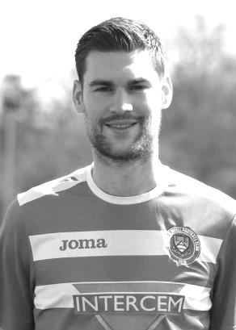
Today, and slightly belated as he was suspended for Tuesday’s match, our Captain Dan Dean should be making his 100th appearance in Epsom colours.

Dan made his debut for us on 2nd August 2014 as did many others in our 2-0 win at Farnham Town on the opening day of that season and he has been a regular for us in that time, taking over the Captaincy from Sam Currie over a season ago now.

Dan is a versatile player, regularly playing in defence but also in midfield . His former clubs include Fulham, AFC Wimbledon, Leatherhead Walton & Hersham, Merstham and latterly Chipstead, from where he joined us.

Congratulations Deano and here’s to many more!

Birthday Corner
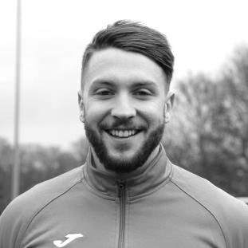
We have a few birthday celebrations for January, starting with Ali Turpie. Our keeper was 25 on Saturday 7th January. Ali has been a useful back up this season and last, since joining us from EIS Pearl CFC, playing out of Doha, Qatar in the Qatari Third Division! I wonder if he still has any contacts there as I note they are sponsored by Etihad Airways and it would be nice to pick up a little sponsorship……! Ali (left) currently has eleven appearances for us with four clean sheets

A day later on 8th January, our striker Rob Hendry (right) celebrated his 27th birthday. He had plenty to celebrate, scoring the day before in our win over Spelthorne Sports and this is a chap that likes to celebrate! His “achievements” whilst in Chantilly in June are almost legendary as was his ability to then score two goals in our 5-2 defeat the very next day!

Rob currently has made 74 appearances with 19 goals for the club.

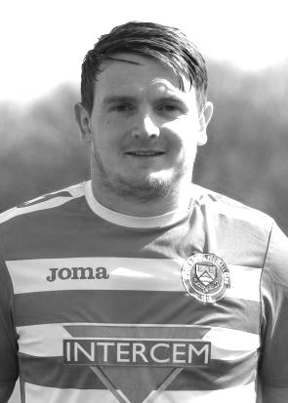
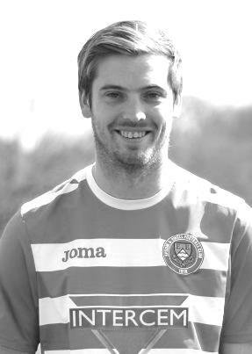
On Wednesday 11th January Elliott Thompson had his 26th birthday. Elliott joined us towards the end of last season and had secured a starting eleven position when we kicked off this term. However, a nasty knee injury at Windsor on 13th August ended his season before it had begun and it will be some time yet before we see him back in Epsom colours.

I am always particularly impressed when players who are unable to play for whatever reason, still come along to support the club and Elliott is very often seen at home and away games. At the time of the injury Elliott had made 16 appearances with just the one goal, scored ironically against today’s opponents in our 9-2 win over there and pictured on today’s cover.

Finally, this very day I celebrate my 50th birthday! I would like a comfortable home win for my birthday present please chaps!

Latest Results and Fixtures
Combined Counties League Cup QF – Tuesday 17th January
Westfield | p-p | Camberley Town
Combined Counties League – Tuesday 17th January
Badshot Lea | p-p | Chertsey Town
Epsom & Ewell | 1-0 | Guildford City
Farnham Town | 1-1 | Walton & Hersham
Horley Town | 3-2 | Bedfont & Feltham
Knaphill | p-p | Bedfont Sports
Raynes Park Vale | p-p | CB Hounslow United
Combined Counties League – Saturday 21st January
Badshot Lea | V | Hanworth Villa
Bedfont Sports | V | Guildford City
Camberley Town | V | Sutton Common Rovers
CB Hounslow United | V | Farnham Town
Colliers Wood United | V | Raynes Park Vale
Epsom & Ewell | V | Bedfont & Feltham
Hartley Wintney | V | Chertsey Town
Knaphill | V | Horley Town
North Greenford United | V | Abbey Rangers
Walton & Hersham | V | AFC Hayes
Westfield | V | Spelthorne Sports
Surrey Senior Cup – Third Round – Tuesday 24th January
Dorking Wanderers | V | Sutton Common Rovers
Tooting & Mitcham United | V | Knaphill
Combined Counties League Cup QF – Tuesday 24th January
Windsor | V | Horley Town
Combined Counties League – Tuesday 24th January
CB Hounslow United | V | Epsom & Ewell
Chertsey Town | V | North Greenford United
Spelthorne Sports | V | Badshot Lea
Walton & Hersham | V | Colliers Wood United
Combined Counties League Cup QF – Tuesday 24th January
Guildford City | V | Raynes Park Vale
Latest Results and Fixtures
Combined Counties League – Saturday 28th January
AFC Hayes | V | Epsom & Ewell
Badshot Lea | V | Bedfont Sports
Bedfont & Feltham | V | Hartley Wintney
Camberley Town | V | Horley Town
Chertsey Town | V | CB Hounslow United
Farnham Town | V | Windsor
Guildford City | V | Spelthorne Sports
Raynes Park Vale | V | Knaphill
Sutton Common Rovers | V | North Greenford United
Westfield | V | Walton & Hersham
Combined Counties League – Monday 30th January
Sutton Common Rovers | V | Windsor
Combined Counties League Cup QF – Tuesday 31st January
Walton & Hersham | V | Raynes Park Vale
Combined Counties League – Tuesday 31st January
AFC Hayes | V | Abbey Rangers
Combined Counties League – Wednesday 1st February
Colliers Wood United | V | Westfield
Combined Counties League – Saturday 4th February
Abbey Rangers | V | Hartley Wintney
Bedfont Sports | V | Westfield
CB Hounslow United | V | Sutton Common Rovers
Epsom & Ewell | V | Badshot Lea
Guildford City | V | AFC Hayes
Horley Town | V | Farnham Town
Knaphill | V | Colliers Wood United
Spelthorne Sports | V | Camberley Town
Walton & Hersham | V | Hanworth Villa
Windsor | V | Bedfont & Feltham
Combined Counties League – Tuesday 7th February
Bedfont Sports | prov | Epsom & Ewell
Bedfont Sports pitch is being re-laid with a 3g surface and may not be ready

From behind the goal
Hanworth Villa 1-0 Epsom & Ewell
Combined Counties League - Premier Division - Saturday 14th January 2017

No end product at the Ranch

Our second narrow defeat in five days occurred at Rectory Meadow, better known as the Ranch when an early goal from Cyril Ocansey was sufficient for the Villains to secure all three points in an important league encounter.

We made three changes to the team that had been defeated by Guildford City in the Surrey Senior Cup with Michael Eacott back in between the posts for the absent Ali Turpie, while James Taylor and Daryl Cooper-Smith came in for Agi Panayiotou and Reisse Griffin as Glyn rotated the troops, although both would enter the fray later. There were also a few positional changes with Captain Dan Dean moving into midfield, Jordan Gallagher switching onto the right wing and Rob Hendry out on the left.

However, we started well with Hendry winning a corner in the first minute but the Matt Ferdinando corner hung in the air and was easily collected by Bobby Khaira. This would become a depressingly familiar pattern in this match with a number of deliveries from either flank being either too close to the keeper or not clearing the first man. The next corner in was also claimed by Khaira but this time he elected to punch the ball away. However, Ferdinando was waiting on the edge of the area and his superb volley just deflected wide thanks to a defender who had blocked the ball at full stretch.

Despite the good start, the very first time Hanworth crossed the halfway line the ball ended up in our net. The ball was given away in midfield and was flicked on to his team mate by former Salt Tom Neale. As a defensive challenge came in on the striker, the ball squirted off to the side where Ocansey was first to reach the ball, slotting it under Eacott from 12 yards in the 9th minute.

This was harsh on us after our start but we responded well. Matt Tanton made a great run from midfield, beating two players and then thumping the ball from twenty yards off the far post with Khaira rooted to the spot. He scored our goal of the season a few years ago with a fine volley in that very net but this would have been equally special. In fact it was hit so well that the ball rebounded off the post and out of the penalty area where Dean was only a couple of feet wide with a low drive. We followed this up a minute later with a 25 yard strike from Ferdinando which Khaira tipped around the post at full stretch.

We continued to press and a crossfield ball to Hendry out on the left caused trouble as

Khaira came out to get there first but failed as Hendry skipped round him, but he was held up by a defender and in hesitating, the busy keeper got a foot to the ball to concede the corner. The set piece was only half cleared to Tanton on the edge of the area, but his shot appeared to strike Hendry and the grateful Khaira was able to fall right onto it.

The home side had a couple of attempts, one from long range and the other with a glancing header of a left wing cross, but neither were very close to the target and Matt Farrell also went close with another long range drive just before the half before he and Ade Oshilaja both were unfortunate to pick up yellow cards for separate fouls, both of which looked very harsh.

We started the second half a bit slowly and Eacott was out to save a low shot from the right wing before Ferdinando was pulled up for a foul while running at goal. Daryl Cooper-Smith picked up a yellow card for complaining about the decision, and we shared his frustration behind the goal.

A foul from Craig Hastings on the edge of the area gave the opposition a sight on goal and Eacott did really well to make the save to his right for a corner. However, this was one of the very few chances created in the half, which was very scrappy. The referee didn't help the flow of the game either. After applying the advantage law excellently in the first half he got a bit carried away in the second and pulled the game back for a free kick to the home side about ten seconds after the offence occurred. This was stretching the rule a bit and the old inconsistency criticisms would surface later in the match when our substitute Reisse Griffin was badly fouled, only for our advantage to disappear almost immediately, but on that occasion there would be no recall even though the offending Hanworth player would be booked when play finally stopped.

For what seemed the first time in ages, we received the benefit of a refereeing error minutes later after the unhappy Cooper-Smith had lunged in on a home player. Without a doubt this was a second yellow card offence, but luckily for us he remained on the field. Only for about 60 seconds though, as Glyn took him off and replaced him with Griffin. Our sub produced the only decent cross of the entire game in the 69th minute but Gallagher at the far post half volleyed the ball back across goal and just beyond the other post. Gallagher would get space on the left shortly after this but the ball across goal was just in front of the incoming Hendry and the ball went through the six yard box and out for a throw. The pressure continued as Griffin's shot was blocked, although on the counter attack Eacott was down well to cut out Neale's cross.

However, all our hard work was frequently being spoiled by a lack of quality in the final third and the match ended with a Hendry free kick that was blazed over the ball, while Ferdinando a regular scorer from the dead ball watched from a distance, followed shortly after by an Adam Heagney foul throw. We had the whole story of the match summed up in that passage. Over the course of the 90 minutes we did plenty with the ball but at the same time we didn't do enough, if you know what I mean!

Epsom and Ewell: Michael Eacott, Adam Heagney, Matt Tanton, James Taylor,
Craig Hastings, Dan Dean ©, Rob Hendry, Matt Farrell, Daryl Cooper-Smith,
Matt Ferdinando, Jordan Gallagher

Subs: Reisse Griffin for Cooper-Smith (61), Savvas 'Agi' Panayiotou for Hastings (77)

From behind the goal
Epsom & Ewell 1-0 Guildford City
Combined Counties League - Premier Division - Tuesday 17th January 2017

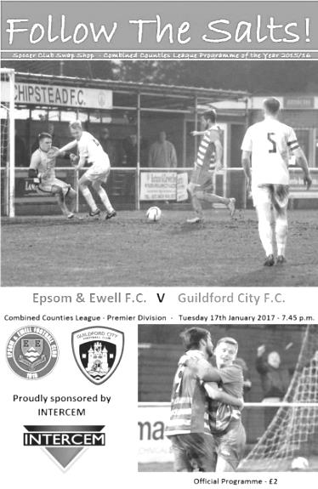
Hastings header turns the tables against Guildford

Did you know that every time Craig Hastings scores for the Salts, not only do we win the match but we keep a clean sheet too! I will concede that statistic is a little tenuous as it is only Craig's second goal for the club, but there were a lot of similarities between this match and the Bridon Ropes Vase tie in which he scored his other goal, as we took a deserved first half lead and in the second kept our opponents at arms length, rarely looking like conceding despite the absence of our suspended Captain Dan Dean.

On a chilly night at Chipstead my car told me that the temperature was minus 2 degrees and that was an hour before kick off. Despite the cold, 37 hardy souls trekked up to High Road with the hope that we could reverse the result against our opponents from seven days previously, and they were rewarded with an entertaining match between two hard working and committed sides. In fairness nobody out there was going to stay still for long!

We made three changes from Saturday's defeat at Hanworth Villa. In addition to the suspended Dean, Daryl Cooper-Smith was unavailable and Adam Heagney switched to the bench with Reisse Griffin having a run at right back. Jason Nwachukwu came in up front, just behind Rob Hendry, while Savvas 'Agi' Panayiotou slotted in to the midfield holding role where he battled all evening, winning many important tackles.

We had a good opportunity as early as the second minute when Hendry was fouled on the edge of the area but Matt Ferdinando's free kick was high and wide. In fact hitting the target would prove to be the main issue today as Jordan Gallagher curled a shot just over from 12 yards, although admittedly it wouldn't have counted as he had strayed offside.

In the 13th minute we had a free kick and it was a good sign that Hastings was able to win the header, although wasn't on this occasion able to do more than head the ball wide of Luke Badiali's right hand post. Ferdinando was next to try his luck after good work from Nwachukwu, but his shot was deflected wide off a defender with the resultant corner causing no danger.

The visitors had been restricted to two attempts by this stage, one of which was a long range effort that was well over the bar and another that was met by a glancing header but with minimal contact and the ball went well wide. Gallagher then sent a Ferdinando pass over the bar and it was beginning to look a little like Saturday's match at Hanworth Villa where we had much of the ball but did little of quality with it.

In the 39th minute Darryl Siaw either stumbled or was tripped and fell on the ball. Expecting the free kick he stuck out an arm to retrieve the ball but no foul had been given and he was booked for deliberate handball. From the free kick a minute later we extracted the full penalty as Ferdinando sent over a peach of a free kick and Hastings had achieved a bit more separation towards the far post, enabling him to send a textbook header across the helpless Badiali into the opposite corner.

The visitors responded with a 25 yard free kick that had been clumsily given away, but the delivery went straight into the hands of Michael Eacott who finally had a shot on target to save in the 42nd minute. This was the score at the half; a deserved, but precarious lead.

We could and maybe should have had a penalty within 25 seconds of the second half when Gallagher was bundled over from behind, but the referee wasn't impressed and the visitors broke away. Fortunately we were able to snuff out any danger, looking particularly compact around the edge of our own area. Both teams were still committed to attack and next to try his luck was Matt Tanton who won the ball off a defender and let fly from 20 yards but he dragged his shot just beyond the far post, while the visitors also had a long range attempt from 30 yards that Eacott watched as it sailed high and wide.

Ferdinando was next to be involved when he made a mazy run on the right but slipped and landed awkwardly, hurting his arm or shoulder. There were two concerns here as not only was our man injured, but whether the slip on the increasingly freezing surface would give the referee any thoughts of an abandonment, but that was probably because we were winning. In truth the pitch played well all match and this was pretty much the only fall. However Ferdinando soon made way for Adam Heagney, with the young right back assuming his position on the field, with Griffin maybe surprisingly remaining at right back.

In fairness Heagney did well in his advanced role and was unfortunate not to score on a couple of occasions. He had a shot charged down by a defender with the ball dribbling through to the keeper just before our man could reach it, and in the 66th minute Gallagher fed him from the left but his snap shot was straight at Badiali who parried the ball to safety.

We picked up another free kick for handball, this time from their Captain Matt Males, who was extremely unfortunate to receive a booking for it. Hendry's free kick squirmed through the wall and the loose ball was drilled at goal but was deflected away. The second half contained more of a contribution from the visitors though as they began to push us back more. Their main opportunity came with quarter of an hour remaining when they had a free kick out on the touchline. The free header at the near post really ought to have been on target but went wide.

With five minutes remaining a flat kick from Eacott went straight through the middle of the Guildford defence and Hendry was on it and through on goal, but a really heavy touch gave the relieved Badiali the chance to claim the ball. It was nearly an assist for Eacott, but he and the team will be more than happy with the clean sheet. In summary we probably should have put this game to bed earlier but the three points were very welcome and we remain unbeaten at home in the League since August.

Epsom and Ewell: Michael Eacott, Reisse Griffin, Matt Tanton, James Taylor, Craig Hastings, Savvas 'Agi' Panayiotou, Jordan Gallagher, Matt Farrell (c), Jason Nwachukwu, Rob Hendry,
Matt Ferdinando

Subs: Adam Heagney for Ferdinando (58), Alex McKay for Nwachukwu (82)

Bedfont & Feltham F.C. – History
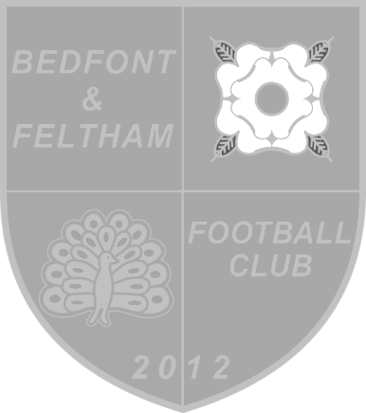
Bedfont and Feltham FC was formed in May 2012 following the amalgamation of Feltham FC (formerly Tudor Park, founded in 1946) with landlords Bedfont Football and Social Club (originally founded pre-1900) to produce a senior side built to tackle the difficult competitiveness of Semi-Professional football.

As Feltham's 1st XI had already entered the FA Vase for season 2012-13 the club had to wait until the commencement of season 2013-14 to fully adopt the new name.

The Yellows' first season under the new banner showed evidence of a strong side both on and off the field. The club was amongst the front-runners throughout the early stages of the season, and finished in a respectable fifth place.

Bedfont & Feltham carried on where Feltham FC had left off the previous season - by winning the Middlesex County FA's Premier Cup beating one-time promotion hopefuls Staines Lammas 1-0 in the final. Despite this success, inaugural Manager Wayne Tisson announced his retirement at the end of 2013-14, stepping down to take a position on the club's committee.

Season 2014-15 saw a new Manager, Dean Thomas take the helm and the team started strongly once again; having their best run so-far in both the FA Cup and FA Vase competitions. Thomas had to call it a day by November due to work commitments so was replaced initially by a caretaker Manager – Louis Carder-Walcott who earned his wings over a couple of months, taking full control in early 2015.

The club finished fifth again in the league table and reached two cup finals; beating Worcester Park 4-3 on penalties to win the RPM Records Division One Challenge Cup; and losing 0-3 to Molesey in the final of the Southern Combination Challenge Cup.

For season 2015-16, the club restructured its First XI squad and further evolved the Youth set-up with teams in the Under 8 through to Under 17 age groups. The club started strongly and for the second time in its short history made the First Round Qualifying in the FA Cup and the FA Vase competitions. Carder-Walcott was replaced in February 2016 by former Sheerwater and Frimley Green manager John Cook.

Under Cook the club held its own in the final furlong of the season, and finished second in the table securing promotion to the Premier Division of the Combined Counties Football League. The club is also proud to have reached the final of the RPM Records Division One Challenge Cup for the second consecutive season which was again versus Worcester Park. This time however, Worcester Park were victorious by one goal to nil.

Life in the Premier Division in 2016-17 saw a number of tough score-lines and defeats early on in the season. Manager John Cook resigned in early September was initially replaced by Joe Monks but his tenure was brief with his departure in October. Player Luke Craig held the fort until former Bedfont player Aaron Morgan was appointed Manager in late December 2016.

It is the club’s ambition to turn things around and gain a safe position in the table over the coming months.

First Eleven Appearances 2016/17 - (max 36)
Name | Debut | 2016/17 |  |  |  | Career Totals
 |  | App | Sub | Total | Goals | App | Sub | Total | Goals
CLARK-GLEAVE Charlie | 23/08/2016 | 3 | 2 | 5 | 0 | 3 | 2 | 5 | 0
COOPER-SMITH Daryl | 03/01/2015 | 25 | 3 | 28 | 25 | 55 | 11 | 66 | 45
DEAN Dan | 02/08/2014 | 25 | 2 | 27 | 0 | 93 | 6 | 99 | 2
DEWAR Ali | 29/10/2011 | 0 | 1 | 1 | 0 | 55 | 36 | 91 | 10
EACOTT Michael | 02/08/2014 | 28 | 0 | 28 | 0 | 113 | 1 | 114 | 0
FARRELL Matt | 02/08/2014 | 34 | 0 | 34 | 14 | 120 | 4 | 124 | 32
FERDINANDO Matt | 20/09/2014 | 19 | 6 | 25 | 3 | 72 | 12 | 84 | 17
GALLAGHER Jordan | 07/08/2016 | 22 | 12 | 34 | 9 | 22 | 12 | 34 | 9
GRIFFIN Reisse | 08/08/2015 | 26 | 6 | 32 | 2 | 54 | 12 | 66 | 4
HASTINGS Craig | 08/08/2015 | 24 | 6 | 30 | 2 | 61 | 10 | 71 | 2
HEAGNEY Adam | 16/08/2016 | 23 | 5 | 28 | 0 | 23 | 5 | 28 | 0
HENDRY Rob | 08/08/2015 | 26 | 7 | 33 | 7 | 56 | 18 | 74 | 19
MCKAY Alex | 20/12/2008 | 16 | 4 | 20 | 3 | 124 | 34 | 158 | 11
NEALE Tom* | 13/10/2015 | 6 | 5 | 11 | 7 | 22 | 24 | 46 | 17
NORTH Rhys* | 16/08/2015 | 2 | 2 | 4 | 0 | 19 | 9 | 28 | 1
NWACHUKWU Jason | 01/10/2016 | 6 | 10 | 16 | 0 | 6 | 10 | 16 | 0
PANAYIOTOU Savvas | 03/01/2015 | 28 | 4 | 32 | 4 | 60 | 12 | 72 | 11
PRICE Matt* | 23/08/2016 | 2 | 0 | 2 | 1 | 2 | 0 | 2 | 1
ROBINSON Sam* | 22/10/2011 | 7 | 1 | 8 | 1 | 61 | 6 | 67 | 14
ROSE Daniel | 25/10/2016 | 2 | 5 | 7 | 0 | 2 | 5 | 7 | 0
SALEH Mennar* | 24/09/2016 | 0 | 2 | 2 | 0 | 0 | 2 | 2 | 0
SMITH Matt | 08/08/2009 | 0 | 2 | 2 | 1 | 91 | 45 | 136 | 11
TANTON Matt | 02/08/2014 | 31 | 1 | 32 | 1 | 88 | 5 | 93 | 3
TAYLOR James | 26/08/2013 | 29 | 3 | 32 | 2 | 115 | 15 | 130 | 8
THOMPSON Elliott | 09/02/2016 | 3 | 0 | 3 | 1 | 7 | 9 | 16 | 1
TURPIE Alistair | 31/03/2016 | 8 | 1 | 9 | 0 | 10 | 1 | 11 | 0
WATRET Jack* | 02/08/2016 | 1 | 0 | 1 | 0 | 1 | 0 | 1 | 0
* player has left the club

Club Records - 21st January
Date | Day | Competition |  | Opponents |  | Scorers
21/01/28 | Sat | London League | H | Mitcham Wanderers | 2-1 | R.Marlow, W.Challis
21/01/33 | Sat | Surrey Senior Cup 1 | H | Tooting & Mitcham United | 1-2 | R.Marlow
21/01/39 | Sat | London League | A | Finchley | 0-2
21/01/50 | Sat | Friendly | A | Rainham Town | 0-5
21/01/56 | Sat | Corinthian League | H | Eastbourne | 4-0 | B.Jenkins, J.Berry, J.Sorensen, D.Hermitage
21/01/61 | Sat | Corinthian League | H | Edgware Town | 1-5 | B.Hawkins
21/01/67 | Sat | Athenian League 2 | H | Ruislip Manor | 6-5 | T.Farmiloe (2), T.Williams (2), T.Stafford, o.g.
21/01/78 | Sat | F.A. Vase 4 | H | Eastbourne United | 0-3
21/01/82 | Thur | F.A. Trophy 1 | A | Cheltenham Town | 3-2 | T.Coombe, T.Tuite, S.Hill
21/01/84 | Sat | Isthmian League 1 | A | Hertford Town | 3-0 | S.Hill (2), M.Spratt
21/01/86 | Tue | Isthmian League  Premier Division | A | Slough Town | 4-4 | M.Spratt, T.Tuite, M.Gillings, P.Kemp
21/01/89 | Sat | F.A. Vase 4 | H | Hailsham Town | 1-2+ | R.Strong (pen)
21/01/92 | Tue | Isthmian League 3 | H | Bracknell Town | 1-1 | A.Webster
21/01/95 | Sat | Isthmian League 3 | A | Camberley Town | 2-2 | S.Miller (2)
21/01/12 | Sat | Combined Counties  Premier Division | A | Croydon | 2-2 | M.Jarman (2)
21/01/14 | Tue | Combined Counties  League Cup 3 | A | South Park | 2-1 | K.Hough (pen), J.Taylor
Historical Decades
90 years ago – Epsom Town F.C.
22/01/27 | Sat | Surrey Senior Cup 1 | H | Woking | 3-8 | W.Challis, T.Birch, J.Parr
80 years ago – Epsom F.C.
23/01/37 | Sat | London League | A | Grays Athletic | 1-4 | G.Brogdale
70 years ago – Epsom F.C.
18/01/47 | Sat | Friendly | H | Crystal Palace 'A' | 9-2 | G.Brogdale (4), H.Wigham (3), J.Chennell, F.Chitty
60 years ago – Epsom F.C.
19/01/57 | Sat | Friendly | H | Woodford Town | 5-2 | B.Jenkins (4, 2 pens), B.Hayes
50 years ago – Epsom & Ewell F.C.
21/01/67 | Sat | Athenian League 2 | H | Ruislip Manor | 6-5 | T.Farmiloe (2), T.Williams (2), T.Stafford, o.g.
40 years ago – Epsom & Ewell F.C.
22/01/77 | Sat | Surrey Senior Cup 1 replay | H | Walton & Hersham | 1-2 | G.O'Rourke
30 years ago – Epsom & Ewell F.C.
31/01/87 | Sat | Isthmian League 1 | A | Staines Town | 3-0 | S.Hill (2), A.Mair
20 years ago – Epsom & Ewell F.C.
25/01/97 | Sat | Isthmian League 3 | A | Southall | 3-2 | T.Boorman, A.Boxall, o.g.
10 years ago – Epsom & Ewell F.C.
20/01/07 | Sat | Combined Counties  Premier Division | H | Bedfont | 1-0 | A.Myers

History Corner – 21st January
90 years ago this week Isthmian League Woking visited us at West Street in the Surrey Senior Cup. We had hoped for better things, especially as we were riding high in the Surrey Senior League (which we would win again) and had Reg Marlow up front setting all sorts of goal scoring records. In fact he had scored a hat trick in his last three matches. Unfortunately he went down with flu and was unable to play, and despite goals from Wilfred “Bronk” Challis, Terry Birch and the ill-fated Jack Parr we were no match for them, losing by eight goals to three. Marlow would return the following week, scoring a fourth and then a fifth consecutive hat trick against Reigate Priory in both League and League Cup matches seven days apart.

60 years ago this week Brian Jenkins scored four goals in another friendly match, this time against Woodford Town who were dispatched 5-2 at West Street. Brian Hayes scored the other goal. Jenkins would go on to have further success, firstly with Sutton United but mainly at Walton & Hersham where he won the Surrey Senior Cup amongst other honours.

50 years ago today we hosted Ruislip Manor at West Street and won 6-5! Goals came frequently and we led 4-2 at half time but held on to win. We have never had another 6-5 result in our history, before or since!

The Player/Manager back then was Tony Williams, who had played for Kingstonian, Corinthian Casuals and Dulwich Hamlet, but would be known in future for the F.A. Year Books and then the Non-League Year Book which still issues. He scored two of the goals as did Tony Farmiloe, while Ted Stafford and an own goal completed the scoring. (see programme pictured)

30 years ago this week the Ricky Kidd revolution was taking shape. He had replaced Alan Webb as Manager in September of 1986 but we had struggled badly until Christmas. We went to Staines in uncertain mood but needn’t have worried as Steve Hill returned to the team and scored twice in our 3-0 win at Wheatsheaf Park with Alex Mair scoring the other goal. Regrettably though, the damage was done by then and even with a young Matt Elliott in our team for the whole season we would suffer our second consecutive relegation.

28 years ago today we were knocked out of the F.A. Vase by Sussex League Hailsham Town at West Street. This was a tight match on a wet day and we took the lead early in the second half through a Richard Strong penalty. However, with just three minutes remaining and a place in the last 16 looking likely, they equalised and won the tie with a penalty of their own in extra time. We couldn’t complain, having squeaked past Banstead Athletic, Three Bridges and Wick (after a replay). All four of those matches had required extra time for us to progress and in the three ties we won, we had been trailing towards the end in each of them!

Surrey Senior Cup
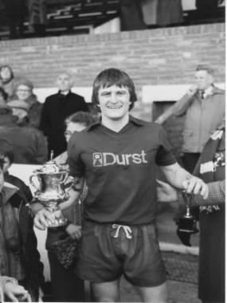
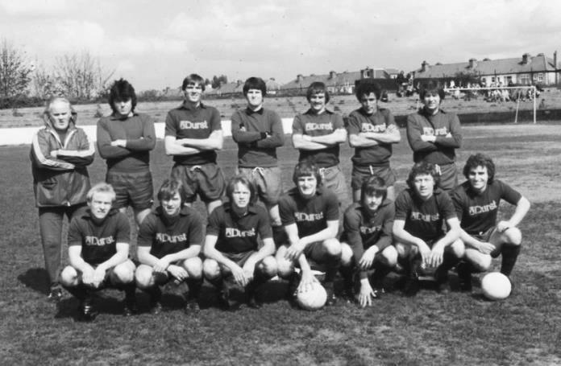
Second Round
Met Police | 0-0 | Kingstonian
Match played at Met Police F.C. – Kingstonian won 7-6 on penalties
Ashford Town (Mx) | 0-1 | Knaphill
Woking | 4-0 | Walton Casuals
Whyteleafe | 5-1 | Colliers Wood United
Guildford City | 3-3 | Horley Town
Guildford City won 3-2 on penalties
Egham Town | 3-0 | Corinthian Casuals
Godalming Town | 0-1 | Merstham
Molesey | 0-1 | Leatherhead
Raynes Park Vale | 1-1 | Sutton United
Raynes Park Vale won 4-3 on penalties
Sutton Common Rovers | 5-1 | Camberley Town
Dorking Wanderers | 2-1 | South Park
Badshot Lea | 1-0 | Farnham Town
Walton & Hersham | 3-0 | Croydon
Carshalton Athletic | 0-2 | Tooting & Mitcham United
Chertsey Town | 2-1 | Abbey Rangers
Epsom & Ewell | 3-0 | Chipstead
Third Round
Whyteleafe | 24/1 | Egham Town
Badshot Lea | 0-2 | Raynes Park Vale
Epsom & Ewell | 1-2 | Guildford City
Dorking Wanderers | 24/1 | Sutton Common Rovers
Chertsey Town | 1-0 | Kingstonian
Woking | 2-0 | Leatherhead
Merstham | 5-1 | Walton & Hersham
Tooting & Mitcham United | 24/1 | Knaphill

EL Records Premier Challenge Cup
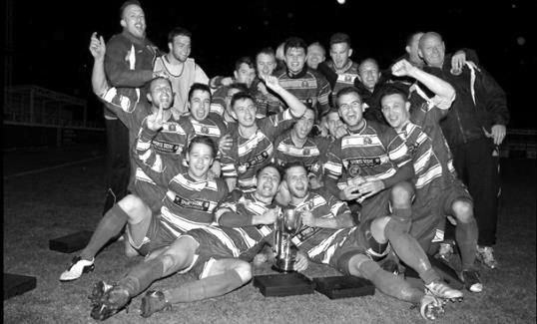
Second Round
Hanworth Villa | 2-4+ | Epsom and Ewell
AFC Hayes | 3-4 | Balham
Epsom Athletic | 1-5 | Windsor
Sutton Common Rovers | 2-1 | Bedfont Sports
Raynes Park Vale | 2-0 | Colliers Wood United
Frimley Green | 1-2 | Banstead Athletic
Westfield | 8-4+ | Redhill
Staines Lammas | 0-1 | Farnham Town
Worcester Park | 8-1 | Cove
Badshot Lea | 0-5 | Guildford City
Chertsey Town | 1-2 | Camberley Town
Cobham | 1-3 | Chessington & Hook United
Hartley Wintney | 4-0 | AC London
Horley Town | 2-2+ 5-4p | Sheerwater
Walton & Hersham | 5-1 | Eversley & California
Ash United | 2-0 | Farleigh Rovers
Third Round
Banstead Athletic | 4-4+ 3-4p | Westfield
Sutton Common Rovers | 1-3 | Walton & Hersham
Farnham Town | 0-4 | Camberley Town
Ash United | 0-2 | Windsor
Raynes Park Vale | 2-1 | Hartley Wintney
Guildford City | 2-1 | Balham
Horley Town | 2-0 | Chessington & Hook United
Worcester Park | 3-6 | Epsom & Ewell
Quarter Finals
Windsor | 24/1 | Horley Town
Guildford City | 25/1 | Raynes Park Vale
Westfield | 14/2 | Camberley Town
Walton & Hersham | 31/1 | Epsom & Ewell

F.A. Vase
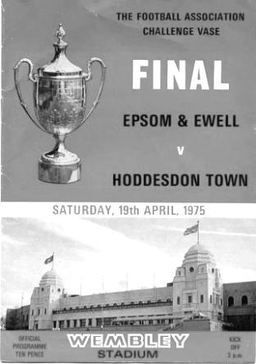
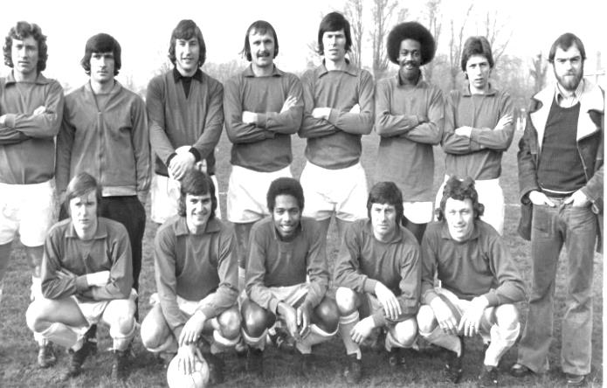
Fourth Round – 7th January
Shildon | 1-4 | Atherton Collieries
Billingham Town | 1-2 | Cleethorpes Town
AFC Mansfield | 0-1 | Sunderland RCA
South Shields | 2A4 r 4-0 | Morpeth Town
Gorleston | 0-3 | Coleshill Town
Sun Sports | 0-4 | Bromsgrove Sporting
Newport Pagnell Town | 3-2 | Peterborough Sports
Sporting Khalsa | 1-0 | Tring Athletic
Ely City | 3-0 | Shepshed Dynamo
Hinckley AFC | 5-0 | Berkhamsted
Bradford Town | 2-4+ | Southall
Bristol Manor Farm | 1-1 r 5-3 | Melksham Town
Chichester City | 1-3 | Buckland Athletic
Team Solent | 3-0 | Croydon
Exmouth Town | 4-0 | Corinthian
Crowborough Athletic | 6-0 | Eastbourne Town
Fifth Round – 28th January
Cleethorpes Town | V | Atherton Collieries
Southall | V | Exmouth Town
Bromsgrove Sporting | V | Bristol Manor Farm
Crowborough Athletic | V | Coleshill Town
Hinckley AFC | V | Buckland Athletic
Newport Pagnell Town | V | Sunderland RCA
Ely City | V | Sporting Khalsa
Team Solent | V | South Shields

My Club Betting
We can now announce that Epsom & Ewell F.C.
now have our own betting site!

If you like to have a bet, this is most definitely for you.

In conjunction with MyClubBetting.com you can now access all the regular markets that you might do regularly with just a click on our website.

But why would you do this? Many of you already might have apps that you currently use.

The main reason is that you would benefit the club by doing so, but at the same time would not lose out yourselves. Their odds are at least comparable and in many cases better than the other bookmakers out there and by registering with us, the club would make 20% of any cumulative losses and with enough usage, we would qualify for other fairly substantial club benefits.

If you win the bet that you place, that is fantastic news, but whichever company you use currently would keep 100% of any losses. This way our club can receive a nice lump sum in the event that you are unlucky.

For example. If we have 20 people signed up and they lost £25 over the month each, our club would receive £100 back out of the £500 lost.

So just visit: https://eefc.myclubbetting.co.uk/ and join the club!

Player Sponsorship
Here is the current list for the 2016/17 season showing all of our players and Management that are available for sponsorship.

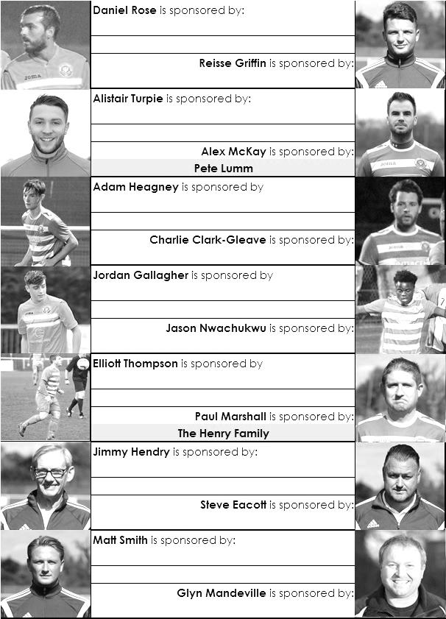

Sponsorship costs just £40 and it is easy to do. Just select a player who has not been previously sponsored and let a Committee Member know that you would like to sponsor them. Beware though. Until we have received the money it is possible for someone to jump in front of you, so don’t delay, sponsor today!
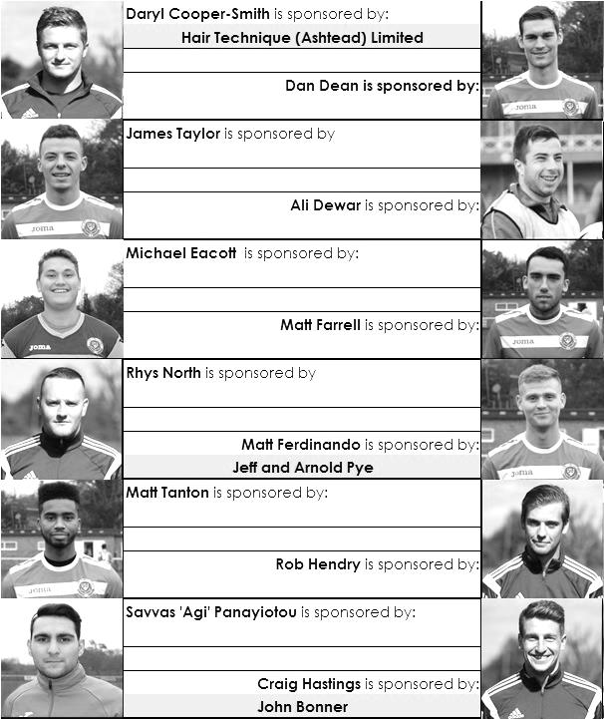

Centre page for results

Centre page for results

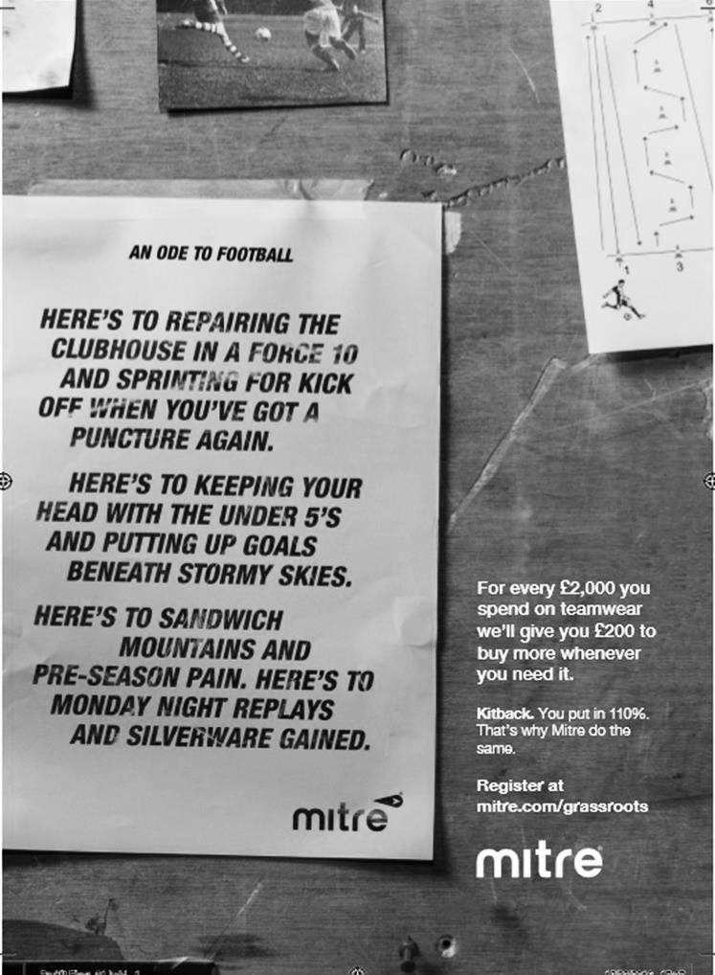

Epsom & Ewell Supporters F.C. – Who were they?
On Sunday 14th December 1986 a football match took place on the Meadowbank hill overlooking Dorking Football Club. This was the first official match played by the Epsom & Ewell Supporters F.C. Sort of!

There were earlier matches before this official formation date. From the early eighties our club sponsor Durst, a local camera company, used to put a team together to play a group of supporters at the end of the season for the Durst Trophy. I played in the match in May 1986 when Durst, aided by an employee who also played in the Epsom & Ewell F.C. First Team, David Jones, defeated us 4-1, although I did manage to score a header near the end!

Anyway, a number of friends who were considered too young, or maybe not long-serving enough as supporters to play in that match used to play football with a few of us in Gibraltar Recreation Ground, next door to our old home at West Street. Because I was a year older than most of them, I was asked whether I would manage a few of them in entering a team for the Metropolitan Police Five a Side competition that summer. We got to the Regional Finals and everyone enjoyed the experience so we started to think about playing regularly.

Then, during the early part of the new season and in discussion with a friend Paul McGuinness, now Paul Stewart, it was agreed that he would put together a team from Dorking F.C. to play us on their ground at Meadowbank. This was obviously an attractive proposition, although by the time the match was played it was nearly Christmas and we were unable to use the ground itself, due to it being a little boggy. So we moved up onto the hill and promptly beat them 10-0 in the first proper match. The first goal for our newly hatched club came from Robbie Cope, whose uncle is the long serving supporter Barry Channell.

Epsom and Ewell F.C. donated a kit that they had used just the once, when the BBC had covered a match between Kingstonian and Epsom & Ewell on 5th March 1983. Because the BBC didn’t allow advertising, our main sponsor Durst couldn’t be featured, so PORST was emblazoned on the kit instead! They allowed us to play a return match with Dorking on the West Street pitch on 27th April 1987 where we were able to complete a double with a 4-1 win. Three days later, also at West Street we played the Annual match against Durst, which was scoreless at the half, but an improvement in the second half ended with a 4-0 victory for the supporters and I was able to lift what would prove to be the very last Durst Trophy.

Another of the players that day was a youngster by the name of Nick Cawthorne who would go on to play for the Epsom First team, while in goal was Doug Kenchington, son of Epsom Manager and Wimbledon legend Peter, and whose son Guy would play for our Reserves.

There had been a little bit of friction during this match as the club had understandably wanted true supporters to play, some of whom had not been involved during the season with the new Supporters team. Also, some of the Supporters team were only occasional followers of the club, so could hardly deserve to take the place of people who had regularly watched. As it turned out the new club would start to arrange matches for the 1987/88 season as it grew in strength, albeit away from Epsom & Ewell F.C. There was no disagreement, and the club also allowed our Supporters team to have function evenings in the old clubhouse from time to time, it was just that as we grew, some people would join who had no real affinity with the parent club. I suppose it was always going to be that way.

There were still appearances by regular supporters like Glen Connett, Gary Vickers, Ray Baxter, Cope and John Steinmetz, with another future Epsom First teamer Steve Packer making an appearance. Regulars in the team back then included keepers Seb Pereda and Kev

“the Cat” Fitzgerald, utility players Darren “Sharon” Shaw, Simon “Simod” Follett and Tim Wood, defenders Daren “Dolly” Pett and Russell “Henry” Greenwood and strikers Rupert Millington and Mark Rymer. All had a number of nicknames, some of which were even printable! I was called Bobby, as the England Manager at the time was Bobby Robson so I suppose it was a natural fit. It could have been a lot worse!

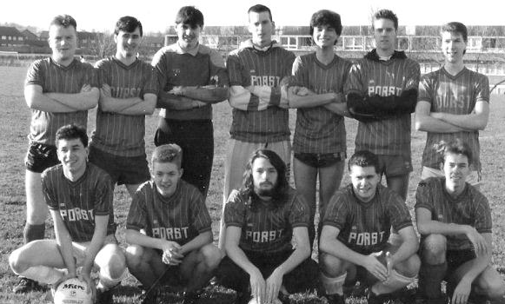
The Supporters on 22/01/89 in a 5-1 loss to Sutton Town at the Roundshaw Playing Fields
Back: Kevin Fitzgerald, Richard Lambert, Seb Pereda, Neil Rollinson, Andy MacKay, Craig Tutton, Tim Wood
Front: Ray Baxter, Robbie Cope, John Steinmetz, Damon Osborne, Darren Shaw

In addition to Meadowbank and West Street, the following season saw us pitching up on the old hospital grounds. We played at Manor Hospital, Horton Hospital, (right next door, although I didn’t realise it at the time to Epsom’s first senior ground) the Hook Road Arena and even Longmead Road, under a site now covered by the old people’s home at the Epsom end of the road that had previously been part of the school playing fields.

We played against teams of other mates sometimes but also played Waitrose, Marks & Spencer, Camberley Town Supporters and even a Glyn Old Boys XI that season, but arguably the most important date was Sunday 3rd January 1988, when some of the regulars approached me about entering a team into a local league. If I’m honest, I thought it was a little too soon for us, but between myself and John Steinmetz, the club Secretary in those formative years, we started to meet the criteria required to enter a team in the Leatherhead & District League. We failed, although we would be accepted for the 1988/89 season.

So another season of friendlies awaited us. We played 19 of them against other fledgling teams like Sutton Town, Station Park, Chessington Computer Centre and renewed acquaintances with Dorking Supporters and also Kingstonian Supporters. We achieved what would become our record winning score of 19-2 on 19th March 1989 against a team that were also applying for League inclusion, the Hook Venturers ‘B’ Team, before defeating the Kingstonian Supporters 4-3 in Richmond that same afternoon! Our club leading scorer

Damon Osborne had recently joined us and scored six against Hook Venturers. It turned out later that he was a Sutton United fan but we let him off in the end!

The standard of players was improving. In came Sean Agutter while we were rejoined by Stewart Spelling, both former Epsom Youth players. Simon Follett was another regular supporter who joined us this year, playing on either flank, but we found he was better on the left so he could cut in on his right a bit like Jordan Gallagher does these days for our first team. Another regular and reliable player back then was Andy MacKay, a very keen player who was often on the bench but just loved playing.

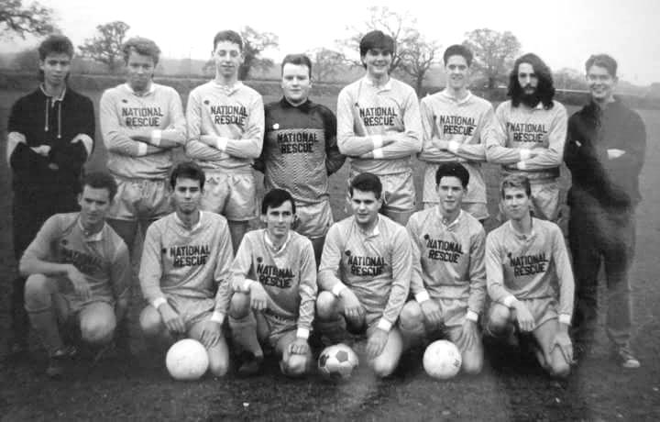
Some of this changed in 1989/90 as we took our first steps into the world of competitive football. New players came into the squad like Lewis “Lego” Owens and his brother Elliott, Andy “Vom” West, Craig “Muttonhead” Tutton and Liam “Frank” Farrell. However, the honour of scoring our first league goal, just minutes into our first ever league match at Ashtead F.C. against Ashtead Park fell to Mark “skinny Vinny” Reilly. We won 3-2 that day, aided by two goals from Lewis Owens and extended the run to three wins out of three in the new Division Seven.

The Supporters on 10/12/89 in their newly sponsored light blue kit at the Hook Road Arena.
However, we still lost 5-0 to Ashtead Park who had strengthened considerably since our opening day 3-2 win
Back: Lewis Owens, Elliott Owens, Andy West, Kevin Fitzgerald,
Liam Farrell, Craig Tutton, John Steinmetz, Daren Pett
Front: Adrian English, Darren Shaw, Richard Lambert, Damon Osborne, Shaun Agutter, Tim Wood

However, disaster struck in the fourth match of the season when we led the Epsom Liberal Club Reserves 1-0 at our home venue of Hook Road Arena with not long remaining, only for a defensive error by yours truly allowing them to equalise. A final second winner from a corner that shouldn’t have been taken as time had expired, consigned us to a 2-1 defeat.

We won our next match on penalties in the League Cup against Stoneleigh Albion, only to

lose 6-4 to the Leatherhead Working Mens Club and we would only win one more league match that season, finishing second from bottom of the 12 team table. Looking back, the most notable event from that season occurred when our match was delayed at the Arena on 12th November 1989. The circus had been in town and there was an elephant tethered to a big oak tree there, not far from our game. The ball ended up over there and it took quite some time before one of the players summoned up the bravery to retrieve it. We only had the one match ball!!

For 1990/91 we found that pitches offered by the Sutton Borough Council were a lot cheaper than those offered by our own, so preceding the parent club by three years we moved out of the Borough and took residence at Poulter Park, near Rose Hill for a season.

We strengthened the team with the addition of former Epsom & Ewell F.C. keeper Andy Syradd, playing, like Michael Eacott does on a Sunday, in midfield and a friend of mine who I knew from working at Legal & General in Kingswood, Steve Tanner. Andy Sutherland, Steve Sherstone and Adrian “Ernie” English also joined the club and would all clock up a number of appearances for us over the years to come. However, a midtable finish was the result. There were some notable results, the most memorable of which regrettably occurred when we had to travel all the way to Dulwich for a Leatherhead League fixture. We eventually arrived an hour after kick off and were promptly stuffed 8-0 but the facilities and food were great!

The Supporters mark their 100th match with a 6-0 League win over Hook Venturers on 6th October 1991
at Royston Recreation Ground in their orange and black kit.
Back: Simon Follett, Lewis Ede, Nick Rose, Liam Farrell, Steve Tanner,
Daren Pett, Andy Syradd, Steve Jaglall, Russell Greenwood
Front: Mick Potter, Damon Osborne, Andy Sutherland, Tim Wood, Richard Lambert, Steve Sherstone

The 1991/92 season was much better. We added Lewis Ede, now one of the Managers at the Colts, and his friend Nick Rose, while also joining was another good player by the name of

Keith Giltname. We decamped to Royston Recreation Ground in Carshalton, a tiny individual pitch venue which was perfect for our needs. We would finish fifth out of eleven that year but we were closer to the top positions that that suggests. Most importantly we reached the League Charity Shield Final, where Tanner put us ahead with a long distance strike, before Surbiton Town, that season’s League Champions turned it around to win 6-1 in a match played at Meadowbank. After all these years we had finally got to play there, even if the result wasn’t quite what we had been looking for! Due to reorganisation we did gain promotion to Division Six so it was quite a good year looking back.

The Supporters wear their red kit for the first time in the Leatherhead & District League Charity Shield Final against Surbiton Town on Thursday evening 23rd April 1992 at Dorking F.C.
Back: Mick Potter, Steve Sherstone, Steve Tanner, Andy Syradd, Liam Farrell,
Steve Jaglall, Keith Giltname, Daren Pett
Front: Richard Lambert, Tim Wood, Andy Sutherland, Kevin Fitzgerald, Simon Follett, Damon Osborne

The 1992/93 season was more difficult. A few regulars were beginning to struggle with the commitment and worse was to come when we turned up to play our first match of the season in Redhill against local rivals Albatross, only to be told that we couldn’t play as we were suspended by the league! Our Secretary at the time hadn’t paid the money required but had neglected to tell us. He resigned soon after which was a pity as it was a genuine mistake. Damon Osborne took over as Secretary while Tim Wood was able to get a number of press releases into the local papers too.

However, we just weren’t quite as good this year and the competition was a little tougher. The worst day was at Wandgas in Worcester Park on 4th October 1992 where we started with 12 men available but finished with 9 due to injury and crashed 9-0! We were already behind by this score with twenty minutes remaining but managed to hold on and as a result the club never conceded 10 in their entire history. We still finished 11th out of 12 though and we were back in Division 7 once again!

We had a couple of new players by this time. Keith Moody the Chip Pig, (sorry can’t explain!) and Marc Morris joined the club in goal along with a very impressive young winger by the name of Stewart Dodd who had moved into the area from the West Midlands and would also go on to play for the main club a year or two later. We moved to Stanley Park, Wallington for the season and were comfortable at the new level, finishing 5th out of 11. A 7-4 Charity Shield win after extra time over Valley Casuals was the highlight in a match that was goalless at half time and required a last minute wonder goal from Dodd to force the extra period.

We also hit double figures twice in the League with a record competitive result of 14-2 against Morden Park in a match played at Poole Road in Ewell as Stanley Road had closed slightly early for the season.

We moved again, this time to Overton Road, Sutton for 1994/95 but with a number of long term players spending a year in Australia! New players Nick Clifford, Steve Thomson, Matt Richardson and John Duke came in, pretty much from the end of the previous season and all became regulars but a second from bottom finish in Division Seven left us facing relegation as there were by now three further divisions below us. Based on the fact that our “travellers” were returning I protested our case for a reprieve at the League meeting and fortunately we were successful in remaining at the same level. This was the start of better things.

Unfortunately we lost Steve Tanner at this point but within a week he had been replaced by Simon Yeung. “Charlie” as he was better known, had played in the higher Divisions and the transition was seamless. With the returning players we battled all the way this year, highlighted by a 5-1 win over Ewell Reserves on 21st January 1996 at Mellows Park. We had lost to this very warm team 6-0 earlier in the season and trailed early but an equaliser and four second half goals handed them their first defeat and we were chasing them. A few of us even went to watch Ewell in their final match, hoping they would lose to hand us the title.

They won the match but we recognised that a certain Paul Harford, the future Sutton United player was playing and knew he wasn’t eligible. We appealed and they lost the points. However, it transpired that they had also played him against the other title contender, Swanderers, a team we had beaten 10-3 earlier in the season, so they were awarded two points which jumped them above us. We were still the runners-up! I remember the League Chairman Phil Furlonger, almost apologising to me for the situation over the phone as he broke the news!

We were moved up two divisions into the Leatherhead Division Five for 1996/97 and by now at Cheam Recreation Ground, where we would remain for much of our remaining life, we strengthened further. Into midfield came Chrisjan Lewis and returning to the team came Nick Rose and Shaun Agutter. Also joining was Lawrence Meakin, another who had played with Charlie at a higher level for the now defunct League of Gentlemen team. In goal Phil Grinter joined us. He had been a regular keeper for many years and replaced Fitzgerald who was by now having to work abroad from time to time.

We reached the Quarter Finals of one Cup and the Semi-Finals of the other but won the League, coming top ahead of Dorking based pub side The Star on goal difference. All of a sudden we were to be in Division Three for 1997/98 where we would have our best ever County Cup run, reaching the last 16 before losing on penalties to Merton Rangers. A big 4-3 win at Cheam Recreation Ground over title challengers Chessington Oracle confirmed that we would be Champions once again and for 1998/99 we were to be in Division One of the League, just one tier behind the big boys.

The Supporters celebrate winning the Leatherhead League Third Division before losing 3-5 to Worcester Park Athletic on 5th April 1998 at Churchfields in Chessington, wearing an impressive dark blue pinstripe kit!
Back: Chrisjan Lewis, John Duke, Adrian English, Phil Grintner, Russell Greenwood, Daren Pett, Richard Lambert
Front: John Dennis, Damon Osborne, Lawrence Meakin, Simon Yeung, Shaun Agutter, Nick Rose, Simon Follett

But the timing was wrong. This was now an aging side that had been in existence for over ten years now. By now I was 31 and was also struggling with pool commitments, a sport I was ten times better at! We also started to struggle for players and then on 15th November 1998 came the wake up call when Shaun Agutter damaged his cruciate ligament just before half time in a match at Churchfields, Chessington against a team called Double H. We had no substitute available and the ten men were beaten narrowly 2-1. Shaun was out for good and would never play again. Others began to question their commitments as they wondered how they would cope in their respective jobs after a similar injury and in that moment for me, anyway, the fun went out of it.

We did get one final huge slice of luck when in February we were defeated in the last minute at home to Langley Vale, due to a horrific refereeing error. I remember telling the referee after the game that he’d just relegated us, and technically I was correct. However, an even poorer error in the League’s administration resulted in us being credited with a 2-1 win instead and we escaped relegation as a result!

With a further season ahead of us in Division One, the time was right for me to call it a day. I believed that the time was in fact perfect for the club to stop at this point as I didn’t want us

To ever have to fold midway through a season, but the players wanted to continue so I had no option but to leave them to it. My pool commitments were requiring more and more time and at the club A.G.M. the Management was passed on to ChrisJan Lewis and the Chairmanship to Damon Osborne. It was a tough ask for them though and the club were relegated in 1999/00 and then failed to complete the 2000/01 season, my worst nightmare.

I recall reading an F.A. Sunday Cup Final programme with a foreword by Graham Kelly, at the time head of the F.A. In it he wrote that the average length of time for a Sunday club is five to eight seasons. We managed 15 and during the 299 matches that I was running the club we had 110 players, of which 13 made more than a hundred appearances. Although there just isn’t room to mention the enormous number of very funny stories from this period, like the Camberley Car Crash, the naked surfing hippy, and the two trips to play in Yeovil, I hope that all of our former players here today will remember some of the memories and they will smile, looking back at the time when we turned from a group of young borderline alcoholics into older confirmed alcoholics that were also able to kick a ball around a bit!

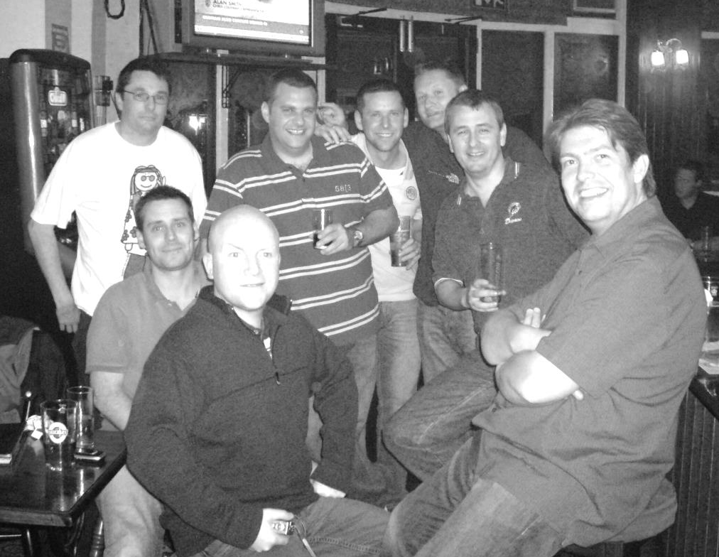
It may have been all about the football at the start, but by the end it was so much more and I wouldn’t have changed any of it! Happy days!

A small Supporters reunion at the Magpie in the early 2000s
From top left and clockwise: John Steinmetz, Damon Osborne, Shaun Agutter, John Duke,
Richard Lambert, Daren Pett, Kevin Fitzgerald, Simon Follett

Every Opponent A-Z
Over the years we have played many, many different opponents. Exactly how many is a difficult question, as it all depends on your definition. Are Camberley & Yorktown different to Camberley Town, or are Epsom Town different to Epsom F.C. or Epsom & Ewell F.C.?

In my analysis I have classed both of the above examples as the same team, and will work through them all from A to Z. Some we have played many times, whilst others we have met just once or twice. Enjoy!

Uxbridge: Played 62 - W19 D5 L38 - F97 A152 - PPG - 1.00 - Poor

Uxbridge are one of the oldest clubs in the country, being formed way back in 1871 and even reaching the Amateur Cup Final in 1898. As we have not met since 1987, it will be surprising to many to learn that we have contested so many matches, sitting fifth on our list of all time opponents and they are only behind Tilbury in the list of non-Surrey meetings.

We met for the first time in a friendly at West Street on 4th February 1933 and winning 3-1 back in the days that friendlies were considered as competitive fixtures (until 1960). We then met just before World War Two when they joined the London League, playing at the R.A.F. Stadium in Northolt, which existed until recently, just off Honeycroft Hill, although a Territorial Army base still remains there. We won 5-2 on our only visit, completing a league double in March of 1939 with a 3-0 win back at West Street.

They remained in the London League when it reformed after the war, as did our club, although Uxbridge appear to have had ground difficulties that season as both matches were played at West Street. It didn’t stop them winning there by an incredible score of 9-3 in October of 1945, although we redressed the balance somewhat with a 4-3 decision in our favour in the following February.

Regular meetings commenced when we moved to the Corinthian League in 1949 where the bulk of our matches took place and we remained as League opponents without a break until 1965. We started with a pair of losses in 1949/50, the latter of which was a heavy 6-2 defeat at their old Honeycroft ground, which was situated off Cleveland Road, near the A4020 in Uxbridge.

We got a draw there in one of our matches the following season as we continued to struggle and in 1951/52 we even defeated them 3-2 at West Street but were again beaten at Honeycroft by 5-2.

In 1952/53 we met three times. This was to be our most successful season in the Corinthian League, with a third place finish and indeed we won both League matches, 6-2 at West Street and 3-0 at Honeycroft, although they knocked us out of the Memorial Shield (the League Cup) 2-1 in Uxbridge despite us carrying a lead into the half.

We lost both matches in 1953/54 but the following season was far worse. We were to finish bottom of the League but before we met in League action they bundled us out of the Amateur Cup by 4-0 at West Street in a performance labelled as “pathetic” by the usually supportive local papers! We were torn apart by their flying winger Brooks, who was referred to in the papers as “coloured”, which was obviously a bit of a novelty back then for the player’s skin colour to be referred to in the first place!

The League results were worse as we lost 7-0 over there and 5-1 there in the Memorial Shield. It was somewhat of a surprise when we then defeated them 3-0 in a League game on Easter Monday at West Street but the damage was done by then and the 5-1 loss in March was our Player / Coach Pat Lynch’s last game for us before the former England Amateur International retired after three years at the helm.

We shared home wins in 1955/56 and even won both matches in 1956/57 without conceding. The

following season we registered our highest ever win over them by six goals to one at West Street before drawing the return 2-2 and at the start of the 1958/59 season we won our first match in the newly created Southern Combination Cup by three goals to nil. The good news ends here!

From this point onwards things took a very bad turn as we were to lose our next six matches, before a narrow 2-1 win at Honeycroft in November 1961 was followed by another eight defeats in a row. Around this time they had a player by the name of Derek Hoddle playing for them and his son Glenn used to regularly attend matches to watch his dad and support his local club!

The final defeat in that long sequence came in February 1968. We had been relegated in 1965 for the first time in our history and they joined us two years later. Our first win for seven years came at Honeycroft, 2-1 in April of 1968 and we repeated the dose 3-2 there in January 1969. However, another six defeats in a row followed. We were into the early seventies by now and we were at our lowest ebb, playing-wise, yet managed a 3-1 win there on New Year’s Day 1972 but in 1972/73 we lost home and away and were rejected by the Athenian League, joining the Surrey Senior League at short notice.

As regular readers know we had two very successful years before returning to the Athenian League as Champions of the Surrey Senior League. Our very first opponents were Uxbridge who beat us 2-1 at Honeycroft, but by 17th April 1976 we were well on our way towards another promotion and goals from Johnny Eales and Paul Butler gave us a 2-0 home win; our first in 14 attempts since 1958!

We went up to the Athenian League Division One but still met the following season in the League Cup, where we required a replay to progress 3-0 at West Street after a 2-2 draw at Honeycroft. This would be the last time we would play at the old venue though as they were forced to move in 1978 and the ground is now covered by part of Brunel University.

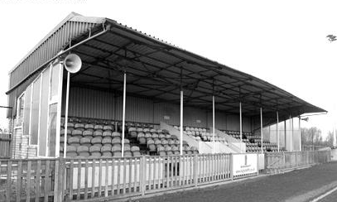
The new ground, also called Honeycroft was first visited by us on 4th February 1986, nine years after we had met in the League Cup Quarter Final. The circumstances were eerily similar as this meeting was also in the Quarter-Final of a League Cup, this time under the auspices of the Isthmian League. Again the first match was drawn after extra time and again the home team won the replay, going on to reach the Final as we had done the previous time.

This was disappointing as we were an Isthmian League Premier Division club back then, but not for much longer and in our fleeting season in Division One before relegation we met twice in league action, drawing 2-2 at Honeycroft in a match where we started with nine men and recovered a 2-0 deficit, before our final meeting on 31st March 1987 when Uxbridge defeated us 2-0 at West Street.

They remained one flight below the Premier Division until 2004 when F.A. reorganisation moved them into the Southern League where they remain to this day as a barometer Step Four club. Their last promotion came in 1985. How dull!

The main stand at the new Honeycroft

Ryman League Division One South Table
incl Tuesday 17th January | P | W | D | L | F | A | Pts | GD
Tooting & Mitcham United | 30 | 20 | 5 | 5 | 85 | 43 | 65 | +42
Dorking Wanderers | 29 | 19 | 4 | 6 | 71 | 35 | 61 | +36
Greenwich Borough | 30 | 19 | 2 | 9 | 69 | 40 | 59 | +29
Hythe Town | 30 | 18 | 4 | 8 | 66 | 43 | 58 | +23
Carshalton Athletic | 31 | 16 | 7 | 8 | 72 | 43 | 55 | +29
Lewes | 29 | 17 | 3 | 9 | 58 | 50 | 54 | +8
Corinthian-Casuals | 28 | 16 | 5 | 7 | 59 | 42 | 53 | +17
Walton Casuals | 31 | 15 | 5 | 11 | 66 | 56 | 50 | +10
Cray Wanderers | 28 | 13 | 8 | 7 | 56 | 50 | 47 | +6
Hastings United | 27 | 13 | 6 | 8 | 81 | 45 | 45 | +36
Horsham | 30 | 12 | 7 | 11 | 60 | 54 | 43 | +6
South Park | 23 | 13 | 2 | 8 | 52 | 35 | 41 | +17
Sittingbourne | 29 | 11 | 8 | 10 | 50 | 54 | 41 | -4
Faversham Town | 26 | 12 | 3 | 11 | 50 | 36 | 39 | +14
Whyteleafe | 29 | 11 | 5 | 13 | 57 | 52 | 38 | +5
Ramsgate | 29 | 9 | 5 | 15 | 45 | 56 | 32 | -11
Herne Bay | 28 | 9 | 5 | 14 | 45 | 62 | 32 | -17
Chipstead | 29 | 9 | 4 | 16 | 43 | 58 | 31 | -15
East Grinstead Town | 29 | 9 | 3 | 17 | 50 | 76 | 30 | -26
Molesey | 28 | 6 | 9 | 13 | 41 | 75 | 27 | -34
Guernsey | 29 | 6 | 7 | 16 | 43 | 74 | 25 | -31
Chatham Town | 30 | 5 | 5 | 20 | 41 | 84 | 20 | -43
Three Bridges | 28 | 5 | 3 | 20 | 38 | 70 | 18 | -32
Godalming Town | 30 | 3 | 3 | 24 | 32 | 97 | 9* | -65
Our latest look at the Ryman League Division One South table shows a surprising name at the top. It’s been a while since Tooting & Mitcham were involved at the business end of any table but they appear to be the real deal, producing some very good results recently.

Of the others in the playoff places, the new name is Greenwich Borough, who came up from the Southern Counties League East as Champions last season. Now based at Cray Valley’s ground which has undergone a substantial makeover, they appear to be as good as anyone else here and may go all the way.

Our landlords are having a slightly better season than last year and although they will continue to look over their shoulder for a while they should have enough to stay safe this time. The same can’t be said about Guernsey yet and it will be interesting to see what would happen if they were to be relegated. Gates have dropped to the 500-600 mark from the four figure attendances they used to have and rumours abound that they may do “a Gibraltar” and decide to play Internationally instead, which looks like a far better option with less outgoings that they currently have with 23 flights to the mainland each season.

At the bottom, Dan Turkington the former Camberley Town Manager becomes the third person to try his luck in charge of Godalming Town this season. He has put in various seven day requests to many top players in our League but the real issue is the travel. In all honesty, come May I don’t think they’ll be travelling quite so far afield and we will be meeting them in League action for the first time since 1927!

Combined Counties League Division One Table
incl Tuesday 17th January | P | W | D | L | F | A | Pts | GD
Banstead Athletic | 21 | 16 | 2 | 3 | 78 | 25 | 50 | +53
Redhill | 22 | 16 | 1 | 5 | 65 | 25 | 49 | +40
Chessington & Hook Utd | 25 | 14 | 5 | 6 | 52 | 31 | 47 | +21
Bagshot | 23 | 13 | 3 | 7 | 58 | 52 | 42 | +6
Eversley & California | 21 | 12 | 3 | 6 | 62 | 45 | 39 | +17
Balham | 21 | 11 | 4 | 6 | 66 | 36 | 37 | +30
AC London | 21 | 12 | 6 | 3 | 66 | 25 | 36* | +41
Cobham | 22 | 11 | 2 | 9 | 51 | 42 | 35 | +9
Sheerwater | 25 | 10 | 3 | 12 | 41 | 62 | 33 | -21
Staines Lammas | 21 | 9 | 4 | 8 | 36 | 34 | 31 | +2
Frimley Green | 23 | 9 | 4 | 10 | 41 | 36 | 30+ | +5
Worcester Park | 19 | 9 | 1 | 9 | 55 | 40 | 28 | +15
Ash United | 21 | 8 | 4 | 9 | 40 | 48 | 28 | -8
South Park Reserves | 20 | 7 | 4 | 9 | 50 | 58 | 25 | -8
Dorking | 24 | 5 | 2 | 17 | 36 | 62 | 17 | -26
Farleigh Rovers | 23 | 4 | 5 | 14 | 41 | 76 | 17 | -35
Cove | 20 | 2 | 3 | 15 | 29 | 82 | 9 | -53
Epsom Athletic | 24 | 2 | 0 | 22 | 13 | 101 | 6 | -88
The most incredible thing about this League table is the fact that Chessington & Hook have played more games in the league than everyone but Sheerwater!

Joking aside, even at this fairly early stage it does look as though we will be making a return visit to Merland Rise and Kiln Brow next season. Banstead Athletic are battling it out with Redhill for the title with both opening up a handy lead on the other clubs.

We could even end up with two visits to Banstead as AC London currently play there too. They had six points deducted for playing a suspended player in the first two matches of the season which has hurt them, but they are still very much involved as are another new team in Balham. Arguably best placed of the chasing pack are Eversley & California and Bagshot, but Chessington & Hook do have the points on the board. It must be remembered that we have 23 in the top flight, so it is possible that only two clubs are promoted this term.

Lower down it is surprising to see Worcester Park so low down the table, especially as when we played them in the League Cup they were on an eight match winning streak. Clearly the rest of their season must have been horrible and they won’t be clogging up the promotion places with their unpromotable facilities this season.

The news is better for those clubs lower down. The Combined Counties League will not relegate a club from this division unless forced to by the F.A for not reaching the required facilities or unless they have a full complement of clubs. I believe they will not relegate unless they have 20, but with 18 there currently, what happens if three new clubs join?

This would spell bad news for the four clubs whose facilities are not Step Six compliant, which are Worcester Park, Staines Lammas, Sheerwater and Farleigh Rovers, with the latter looking the most vulnerable due to league position. For now the clubs currently in the traditional relegation positions, Epsom Athletic and Cove appear safe.

Latest Results Grid
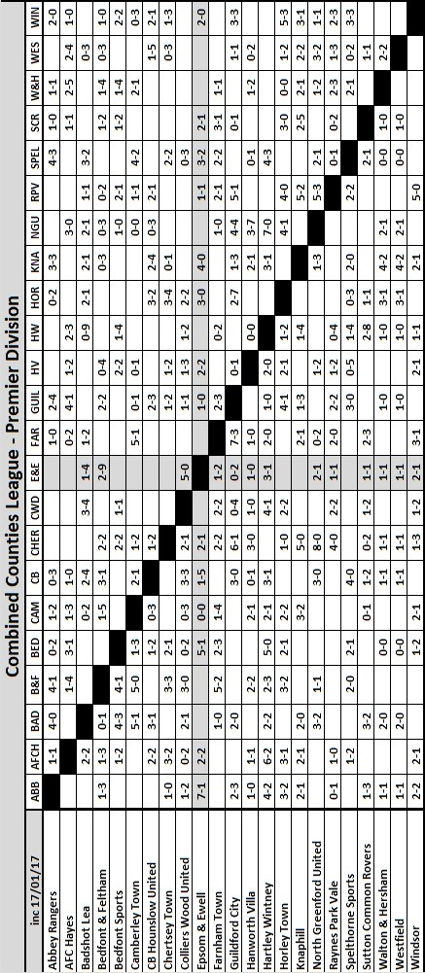

Combined Counties League Premier Division
Opponents All-time Records
incl Tuesday 17th  January | P | W | D | L | F | A | PPG | GD | Best  Win | Worst  Loss
Bedfont & Feltham | 1 | 1 | 0 | 0 | 9 | 2 | 3.00 | +7 | 9-2 | X
Spelthorne Sports* | 6 | 5 | 1 | 0 | 15 | 6 | 2.67 | +10 | 6-2 | X
Sutton Common Rovers | 12 | 9 | 2 | 1 | 30 | 14 | 2.42 | +16 | 4-0 | 1-4
Horley Town | 29 | 20 | 5 | 4 | 65 | 30 | 2.24 | +35 | 6-0 | 1-3
Colliers Wood United | 22 | 14 | 2 | 6 | 45 | 33 | 2.00 | +12 | 4-0 | 0-5
Bedfont Sports | 10 | 6 | 2 | 2 | 18 | 11 | 2.00 | +7 | 5-1 | 0-4
Abbey Rangers | 3 | 2 | 0 | 1 | 10 | 4 | 2.00 | +6 | 7-1 | 2-3
Guildford City | 18 | 11 | 1 | 6 | 35 | 22 | 1.89 | +13 | 5-1 | 1-5
Westfield | 19 | 11 | 3 | 5 | 40 | 31 | 1.89 | +9 | 6-1 | 0-4
Farnham Town | 14 | 8 | 2 | 4 | 25 | 23 | 1.86 | +2 | 3-1 | 1-4
Knaphill | 7 | 4 | 1 | 2 | 15 | 8 | 1.86 | +7 | 4-0 | 1-2
Badshot Lea | 18 | 8 | 3 | 7 | 35 | 34 | 1.67 | +1 | 4-1 | 0-4
Hanworth Villa | 17 | 8 | 4 | 5 | 38 | 27 | 1.65 | +11 | 5-0 | 1-4
Walton & Hersham | 50 | 24 | 10 | 16 | 101 | 97 | 1.64 | +4 | 6-0 | 0-8
Raynes Park Vale | 28 | 13 | 7 | 8 | 59 | 38 | 1.64 | +21 | 6-1 | 0-2
Camberley Town* | 89 | 38 | 22 | 28 | 158 | 123 | 1.52 | +35 | 9-1 | 0-4
Hartley Wintney | 11 | 4 | 3 | 4 | 26 | 20 | 1.36 | +6 | 5-0 | 2-4
Windsor | 49 | 19 | 12 | 18 | 90 | 90 | 1.41 | 0 | 4-0 | 0-6
Chertsey Town | 48 | 18 | 5 | 25 | 72 | 87 | 1.23 | -15 | 3-0 | 0-7
AFC Hayes | 9 | 2 | 3 | 4 | 18 | 17 | 1.00 | +1 | 7-0 | 0-3
North Greenford United | 11 | 3 | 2 | 6 | 15 | 20 | 1.00 | -5 | 3-0 | 1-4
CB Hounslow United | 2 | 0 | 0 | 2 | 2 | 7 | 0.00 | -5 | X | 1-5
* includes one abandoned match v Camberley and one loss on penalties v Spelthorne

Match and Ball Sponsorships – 2016/17
Opponent | Date | Match Sponsor | Ball Sponsor
Gravesham Borough | 07/08/16 | Club President - Stella Lamont
Gravesham Borough | 07/08/16 | Relocation Committee Member - Mike Lovett
CB Hounslow United | 16/08/16 | EEFC Management Committee
Abbey Rangers | 23/08/16 | Steve & Geoff Dyke
Horley Town (11.30am) | 29/08/16 | In Memory of Chris Henry
Abbey Rangers (LC) | 06/09/16 | Paul Merritt
Camberley Town | 10/09/16 | Building Shop Ltd
Knaphill | 24/09/16 | EEFC Holding Company Director – Pete Lumm
Bridon Ropes (FAV) | 22/10/16 | George and Joseph Saunders
Sutton Common Rovers | 08/11/15 | Alex McKay Senior
Abbey Rangers (FAV) | 13/11/16 | EEFC Holding Company Director – Dave Ellins
Windsor | 15/11/16 | In Memory of Wally Dyke
Bedfont Sports | 19/11/16 | John Bonner
AFC Hayes | 26/11/16 | Jack Jarman
Chipstead (SSC / DWT) | 06/12/16 | Trevor Stotten
Hanworth Villa | 13/12/16 | Roger and Carol Farrell
Chertsey Town | 17/12/16
Raynes Park Vale (11.30am) | 27/12/16 | In memory of Dave and Liz Marshall
Spelthorne Sports | 07/01/17 | Building Shop Ltd
Guildford City (SSC) | 10/01/17 | Super Six Winner – Rita Christian
Guildford City | 17/01/17
Bedfont & Feltham | 21/01/17 | Programme Editor - Richard Lambert
Badshot Lea | 04/02/17
Westfield | 18/02/17
Walton & Hersham | 04/03/17
Hartley Wintney | 18/03/17
Farnham Town | 25/03/17
Colliers Wood United (1pm) | 14/04/17 | Good Friday match – make a note!
North Greenford United | 22/04/17 | Club President - Stella Lamont
For League, League Cup and Surrey Senior Cup Matches:
Match sponsorship - £40.00 Match ball sponsorship - £25.00. Combined £55.00.
For F.A. Cup and F.A. Vase matches:
Match sponsorship - £50.00 Match ball sponsorship - £30.00. Combined £65.00.

Sponsorship includes: (x2 for match, x3 for match and ball)

Admission, programmes, hospitality and advertising and mascot for the day (if required).
If you are interested, just speak to a Committee Member, or drop me an email at: richard.c.lambert@gmail.com

We also thank our Kit Sponsors INTERCEM

Salts Super Six Predictor
The Salts Super Six Predictor is live again for today’s match and the tickets are on sale at today’s game to the left of the gate. The matches are to be played this Saturday.

The jackpot is already increasing and is now up to £282.

The competition is easy to play! To win, you simply need to predict the results of six matches correctly from the three options, fill in the form and make sure it is back with our seller before the deadline on the ticket. The latest fixtures are shown below.

If you are a club regular, you just need to place your name on the sheet, although if you aren’t, then we’ll need a contact number from you too. We will announce any winners on the website within three working days, so don’t worry, we won’t miss you!

Please note that if there is more than one winner, the prize pot would be shared between the winners. All you need to do now is have a go, as many times as you like!

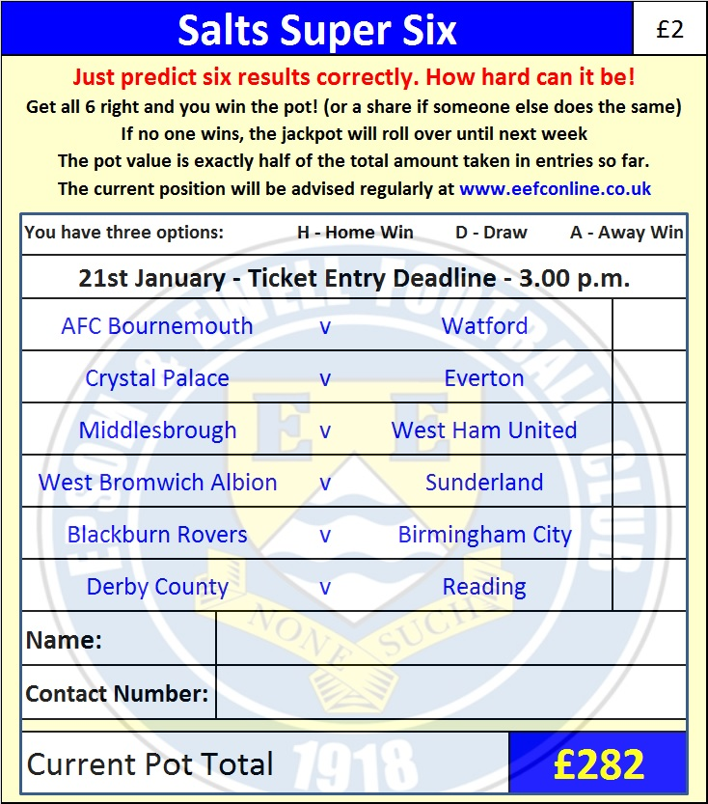

Good luck!

Combined Counties League – Premier Division
Saturday, 21st January 2017 - Kick-off 3.00 p.m.

Epsom and Ewell  (Royal Blue & White hoops) | V |  | Bedfont & Feltham  (Yellow and Blue, Blue, Blue)
Squad | NUMBERS |  | Squad
Michael Eacott |  |  | Keval Patel
Adam Heagney |  |  | Cyrus Vanterpool
Matt Tanton |  |  | Ashley Quashie
James Taylor |  |  | Leon Fisher
Craig Hastings |  |  | Jason Pinnock
© Dan Dean |  |  | Sam Kimbi
Jordan Gallagher |  |  | Shakeel Morris
Matt Farrell |  |  | Frank Vincent
Rob Hendry |  |  | Jacob Lambe
Savvas ‘Agi’ Panayiotou |  |  | Aaron Morgan
Matt Ferdinando |  |  | Melford Simpson
Jason Nwachukwu |  |  | Darren Putman
Reisse Griffin |  |  | Leonardo Pedro
Daryl Cooper-Smith |  |  | Bilal Aaloughe
Alex McKay |  |  | Triston Thomas
Daniel Rose |  |  | Calvin Harrison
Alistair Turpie
Charlie Clark-Gleave
Matt Smith
Glyn Mandeville | MANAGER |  | Aaron Morgan
Matt Smith | ASSISTANT |  | Rob Jermain
Steve Eacott / Alex McKay /  Jimmy Hendry | COACHES / PHYSIO
REFEREE: M.Williams
ASSISTANTS: K.Parker, P.Maskell
Today’s Match and Match Ball are kindly sponsored
by Media Officer and Programme Editor Richard Lambert

OUR NEXT VISITORS TO HIGH ROAD
Badshot Lea
Combined Counties League – Premier Division
Saturday 4th February 2017 – 3.00 p.m.

